



**PROJECT REPORT**

**BRONX LUGGAGE**

**Theme: e-commerce website**

**Category: Website Design & Development**

**PROJECT INSTRUCTOR:**

**MISS. ARUBA**

**Submitted to:** [eProject@aglsm.com](mailto:eProject@aglsm.com)

**GROUP MEMBERS**

STUDENT1502097Maha Asim Khan

STUDENT1505131 Ramsha Ali

**ACKNOWLEDGEMENT**

We would like to say thanks to our project instructor “Miss. Aruba” who gave us the golden opportunity to do this project (Bronx Luggage), which also helped us in doing a lot of research and we came to know about so many new things.

Thank you!

**Task Sheet**

|  |  |  |  |  |  |
| --- | --- | --- | --- | --- | --- |
| **S no.** | **Task** | **Starting date** | **Days** | **Team members names** | **Status** |
| **1.** | Information collecting | 21.10.2023 | 3 days | Maha Asim Khan | **Completed** |
| **2.** | Making logo | 24.10.2023 | 1 day | Ramsha Ali | **Completed** |
| **3.** | Making layout/pages | 25.10.2023 | 5 days | Maha Asim Khan | **Completed** |
| **4.** | Navbar | 30.10.2023 | 2 days | Maha Asim Khan | **Completed** |
| **5.** | Collecting images | 01.11.2023 | 4 days | Maha Asim Khan | **Completed** |
| **6.** | Working on home & gallery page | 5.11.2023 | 3 days | Maha Asim Khan | **Completed** |

**Table of Contents**

1. **Introduction**
   1. Background and Necessity for the Website
2. **Project Overview**
   1. Scope of Project
   2. Constraints
3. **Requirements Analysis**
   1. Functional Requirements
   2. Non-Functional Requirements
4. **Interface Specifications**
   1. Hardware
   2. Software
5. **Design and development**
   1. Architecture of web application
   2. Data Flow Diagram (DFD)
   3. Source Code
6. **User Guide**
   1. System Requirement
7. **Realizing Success: Project Deliverables**
   1. Delivering Excellence: The Fruits of Our Endeavors
8. **Introduction:**
   1. **Background and Necessity for the Website**

In today's fast-paced world, travel has become an integral part of our lives, be it for leisure, work, or adventure. The significance of reliable, durable, and stylish luggage is undeniable. "Bronx Luggage" recognizes the evolving needs of travelers and aims to redefine the way people shop for travel gear. This platform emerges from the necessity to offer a curated selection of premium luggage and travel essentials, catering to diverse preferences and requirements of modern travelers.

The surge in travel, coupled with the increasing expectations for functional and stylish luggage, drives the necessity for "Bronx Luggage." Travelers seek a platform that not only provides a wide array of luggage options but also offers detailed insights into their durability, design features, suitability for different travel purposes, and compatibility with airline regulations. This platform addresses these needs by presenting a thoughtfully curated collection of travel gear and facilitating an informed shopping experience.

The demand for online shopping convenience in the travel industry further fuels the necessity for "Bronx Luggage." Travelers often face challenges in finding the right luggage that aligns with their preferences and travel needs. This digital hub serves as a solution by transcending geographical boundaries and store hours, allowing customers to explore and purchase top-quality luggage at their convenience.

"Bronx Luggage" aims to redefine the travel shopping experience by offering a blend of convenience, reliability, and style. Through its curated collection and informative platform, it strives to be the go-to destination for travelers seeking top-quality luggage and accessories that match their unique preferences and travel needs.

1. **Project Overview**

"Bronx Luggage" redefines the luggage shopping experience by seamlessly blending e-commerce with an immersive exploration of travel gear. Tailored for avid travelers and those seeking quality luggage solutions, this platform offers a comprehensive online journey that simplifies the process of discovering and acquiring a diverse range of travel essentials. By merging shopping convenience with insightful knowledge about travel gear, "Bronx Luggage" aims to be the go-to destination for all things related to stylish, durable, and functional luggage.

Amidst the dynamic landscape of travel, the importance of reliable, aesthetically pleasing, and practical luggage has never been greater. "Bronx Luggage" acknowledges this need and emerges as a digital haven, offering an extensive assortment of luggage options while providing in-depth insights into their features, durability, and suitability for various travel needs.

* Curate an extensive collection of premium luggage and travel essentials that cater to diverse preferences and travel requirements.
* Simplify the shopping experience through intuitive search tools and well-organized selections of luggage, travel bags, and accessories.
* Provide detailed insights into each product, including materials, durability, design features, and suitability for different travel purposes.

**2.1 Scope of Project**

This Web portal will be a responsive and visually appealing Website to be used by individuals.

**2.2 Constraints**

The web portal will notably lack a storage capability on its server. Instead, data retrieval will be achieved through JSON/TXT files, presenting users with visible content. Nevertheless, the portal will abstain from enabling information alteration within these files directly from its interface.

1. **Requirement Analysis:**
   1. **Functional Requirements**

* **Pages and menus**
* Catalog Display
* About Us
* Navigation
* Luggage Information
* Feedback
* Contact Us

**3.2 Non-Functional Requirements**

* Website Security
* User Accessibility
* Intuitive User Experience
* Operational Reliability
* Optimal Performance
* Scalability
* Continuous Availability
* Cross-Browser Compatibility

1. **Interface Specification**
   1. **Hardware**

Intel Core i5 Processor or higher, 8 GB RAM or higher, Color SVGA, 500 GB Hard Disk space, Mouse, Keyboard

* 1. **Software**

HTML5, CSS3, Bootstrap 5, JavaScript, Draw.io, jQuery.

1. **Design and Development**

* **Architecture of web application**

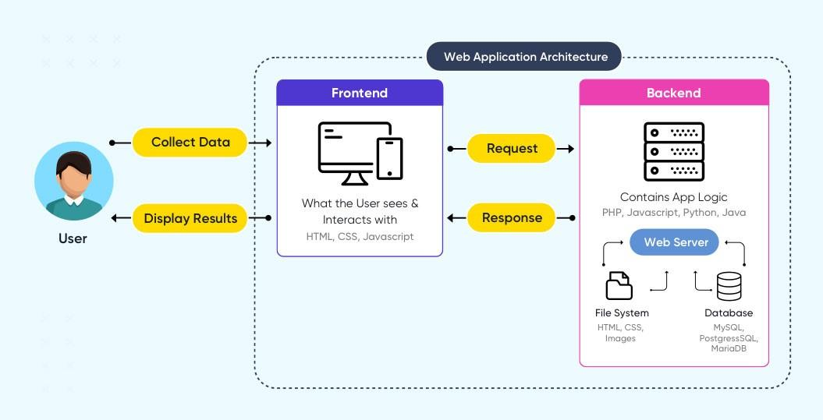

* **Data Flow Diagram (DFD)**

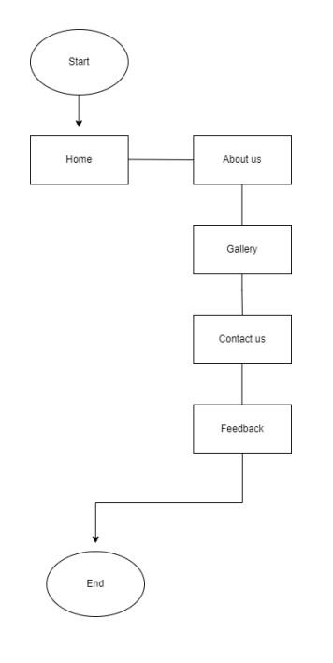

1. **User Guide:**

The thirst for learning, upgrading technical skills and applying the concepts in real life environment at a fast pace is what the industry demands from IT professionals today. However busy work schedules, far-flung locations, unavailability of convenient time-slots pose as major barriers when it comes to applying the concepts into realism. And hence the need to look out for alternative means of implementation in the form of laddered approach.

The above truly pose as constraints especially for our students too! With their busy schedules, it is indeed difficult for our students to keep up with the genuine and constant need for integrated application which can be seen live especially so in the field of IT education where technology can change on the spur of a moment. Well, technology does come to our rescue at such times!!

Keeping the above in mind and in tune with our constant endeavour to use Technology in our training model, we at Aptech have thought of revolutionizing the way our students learn and implement the concepts using tools themselves by providing a live and synchronous e-Project learning environment!

**So, what is this e-Project?**

e-Project is a step by step learning environment that closely simulates the classroom and Lab based learning environment into actual implementation. It is a project implementation at your fingertips!! An electronic, live juncture on the machine that allows you to

* Practice step by step i.e. laddered approach.
* Build a larger more robust application.
* Usage of certain utilities in applications designed by user.
* Single program to unified code leading to a complete application.
* Learn implementation of concepts in a phased manner.
* Enhance skills and add value.
* Work on real life projects.
* Give a real life scenario and help to create applications more complicated and useful.
* Mentoring through email support.

The students at the centre are expected to complete this e-Project and send complete documentation with source code to e-Projects Team

Looking forward to a positive response from your end!!

* **Source Code**

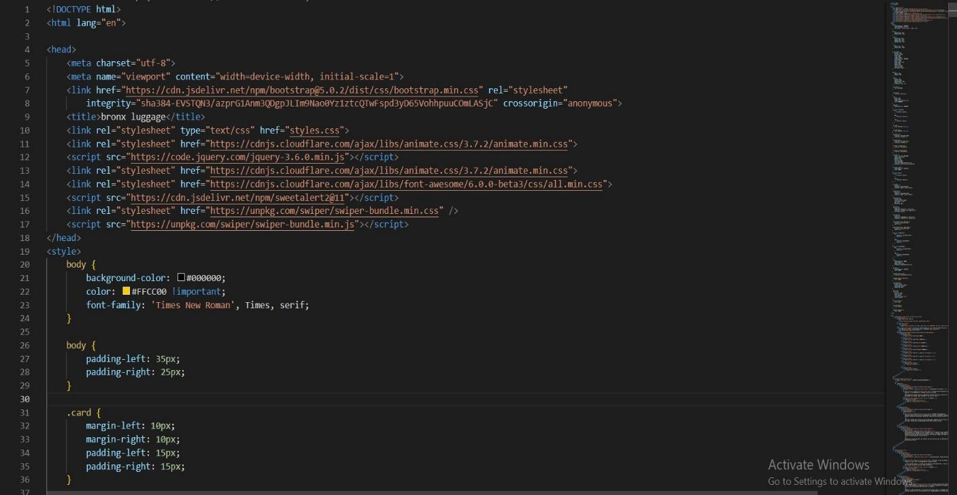

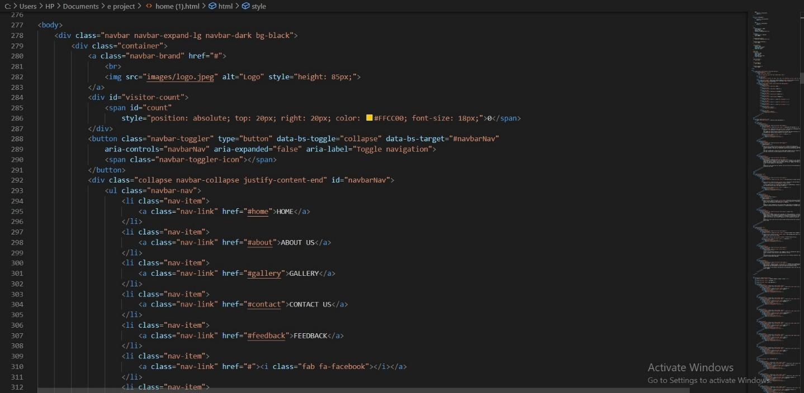

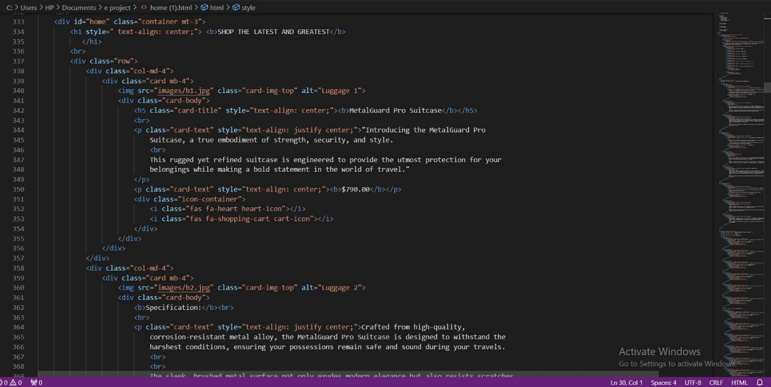

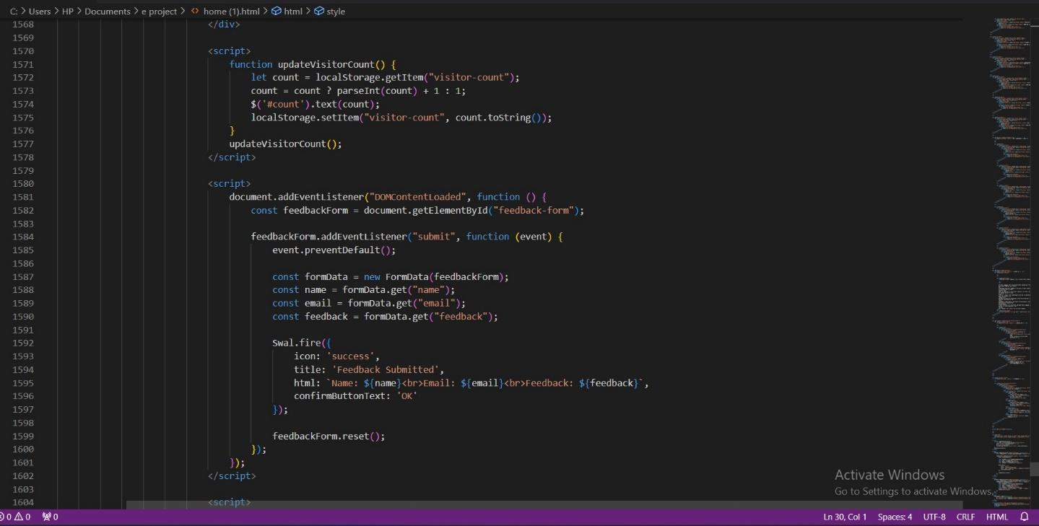

1. **Developer Guide**

The portal will be designed as a Single-Page-Application and responsive Website with a set of pages and menus that represent choice of activities to be performed. The pages, menus, and other visual elements must be designed in a visually appealing manner with attractive fonts, colors, and animations.

All of these should also be laid out in a responsive manner

The Web site is to be created based on the following requirements.

1. The Home Page should be created making use of Sections with a suitable logo, the header section can be added which will show images of various Luggage’s and Bags.
2. The site must contain the sections to navigate through various types of Luggage, Bags and BackPacks etc.
3. Filter for various sizes, colour, price, brands should be provided.
4. Site should have different section for Men and Women with products placed accordingly.
5. Specification and Pricing of Bags should be added along with the images.
6. Website should provide section for various brands offered in the store.
7. Ratings by the user for products should be allowed by the user.
8. Gallery section should be added for viewing different images.
9. Feedback must be allowed to enter by the viewer

10) Gallery, about us, Contact us link must be added.

11) About Us and Contact Us: This menu option should display Email id, address, and contact number of the organization who is developing the system.

* 1. **System requirement**

|  |  |  |
| --- | --- | --- |
| s.no | Items | description |
| 1. | Operating system | Microsoft windows 8.1, 8, 10 or higher |
| 2. | Software | Visual studio code 2017 or higher |
|  |  |  |

1. **Realizing Success: Project Deliverables**

